**Model Development Phase Template**

|  |  |
| --- | --- |
| Date | 2/7/24 |
| Team ID | SWTID1720100721 |
| Project Title | Machine Learning Approach to Predict Price of Natural Gas |
| Maximum Marks | 4 Marks |

**Initial Model Training Code:**

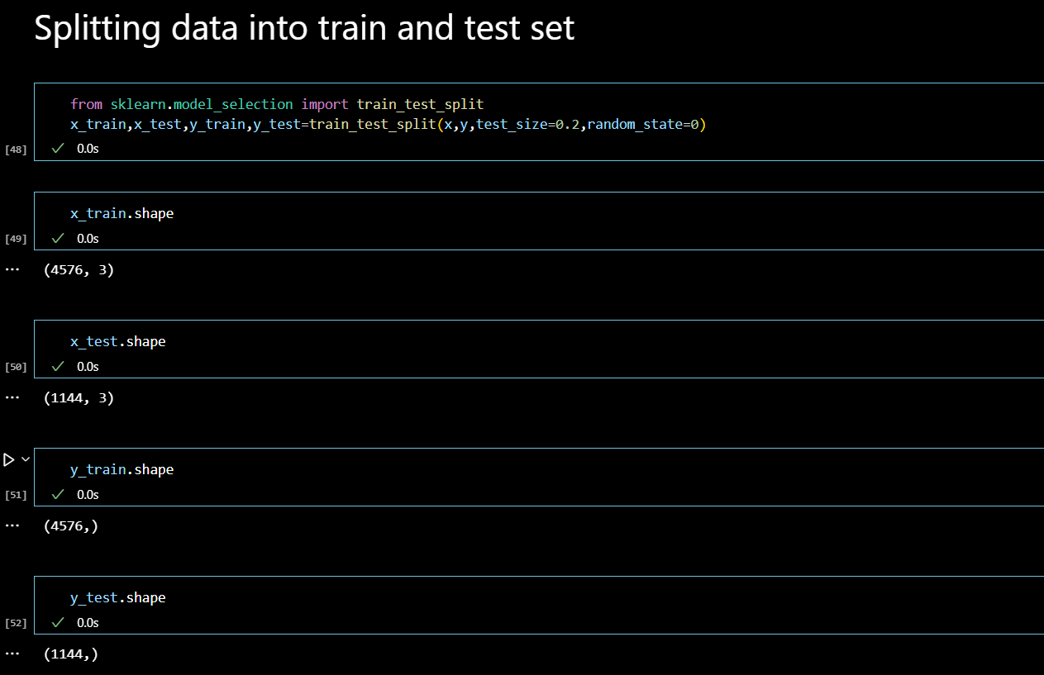

**Model Validation and Evaluation Report:**

|  |  |  |  |
| --- | --- | --- | --- |
| **Model** | **Mean Absolute Error** | **RMSE** | **R2_score** |
| Decision Tree Regressor | 0.19149868435007256 | 0.3097989077262113 | 0.9683899463377701 |
| Random Forest Regressor | 0.12526709401709402 | 0.20780455297442088 | 0.9857775116720077 |